Task Js(2)



Name: Matthew Kamal Saad

Submitted to: Eng. Ahmed Saber
Date: 22/11/2025
INLINE JAVASCRIPT
Inline JavaScript involves embedding JavaScript code directly within HTML element attributes. This method is ideal for simple, small scripts or event handlers.
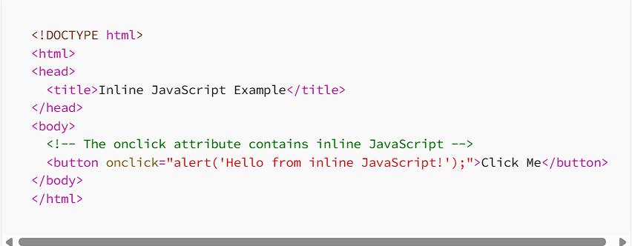

When to Use Inline JavaScript
- Perfect for small scripts or single event handlers.
- Useful during the initial stages of development when testing functionality.
Drawbacks
- It can become messy and hard to manage as your project grows.
- Mixes HTML structure with JavaScript behavior, making the codebase less organized.

INTERNAL JAVASCRIPT
Internal JavaScript is placed within the HTML document inside <script> tags. This method keeps JavaScript code separate from HTML element attributes while still residing in the same file.

Key Characteristics
- Keeps JavaScript separate from HTML attributes, promoting cleaner code.
- All code resides in one HTML file, simplifying deployment for smaller projects.
Considerations
- As the project grows, having all scripts in one file can become unwieldy.
- Mixing content and behavior in a single file might reduce organization for larger applications.
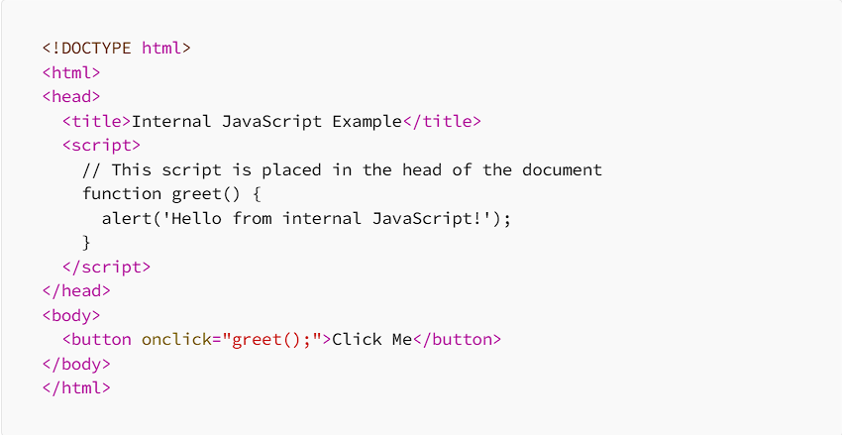
EXTERNAL JAVASCRIPT
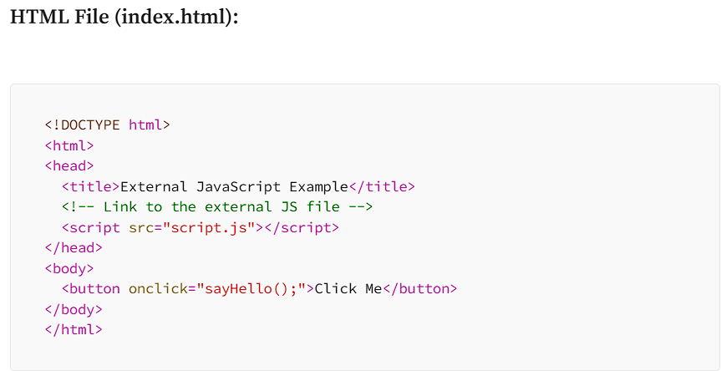
External JavaScript involves placing JavaScript code in separate .js files, which are then linked to the HTML document using the <script> tag with a src attribute. This method is widely preferred for its maintainability, reusability, and clear separation of concerns.

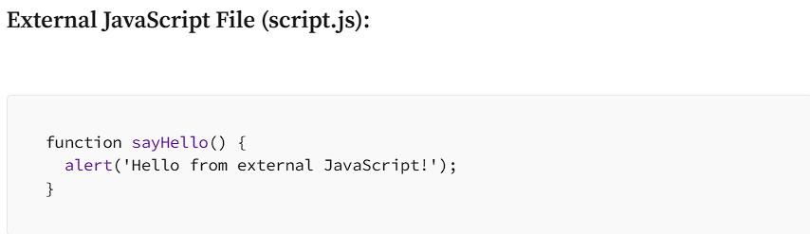

Advantages of External JavaScript
- Clearly separates HTML structure from JavaScript behavior, making the codebase more organized.
- Allows the same JavaScript file to be used across multiple HTML pages, reducing redundancy.

Difference between addEventListener and onClick

- onClick
The. onclick property directly assigns a single function to handle the click event of an element.

How It Works:
- The DOMContentLoaded event ensures the DOM is fully loaded before executing the script.
- The .onclick property assigns a single function to handle the click event on the element with the ID getMessage.
- When the button is clicked, the function sends an HTTP request, parses the response, and updates the element with the class message.

- addEventListener
The addEventListener method allows you to attach multiple event listeners to the same element for the same event.

How It Works:
- Similar to the .onclick method, DOMContentLoaded ensures the DOM is loaded before the script runs.
- addEventListener attaches a click event listener to the button.
- The same actions (sending an HTTP request, parsing the response, and updating the message element) occur when the button is clicked.

